Sample Data Flow Diagrams:

Context diagram
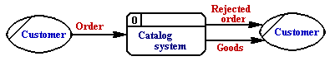
The Top (1st level) DFD
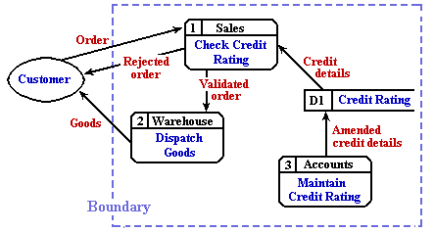

The next step - the Next Level(s)
Each Process box in the Top Level diagram will itself be made up of a number of processes, and will need to be decomposed as a second level diagram.
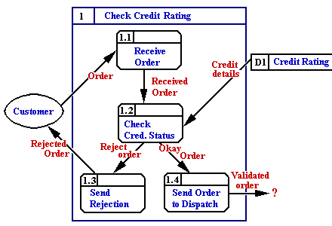

DATA FLOW DIAGRAM

Patient
Healthy Person
HOSPITAL MANAGEMENT

Gets admitted discharged

LEVEL – 0 Data Flow Diagram (DFD)
PATIENT
REGISTER
BILL PAID
TREATMENT
Discharge
Get admitted

LEVEL – 1 Data Flow Diagram (DFD)

Patient
Rooms codification
Patient Registration
Doctors codification
Total bill paid
Discharge
Diagnosis and Treatment
Allot room if empty
Assign doctor
Bills generated
Diagnosis and Treatment

